21BDS0340

Abhinav Dinesh Srivatsa

Exploratory Data Analysis Lab

Experiment – V

**Code:**

library(dplyr)

library(missForest)

library(mice)

library(VIM)

library(ggplot2)

library(cowplot)

data = iris

View(data)

**Output:**

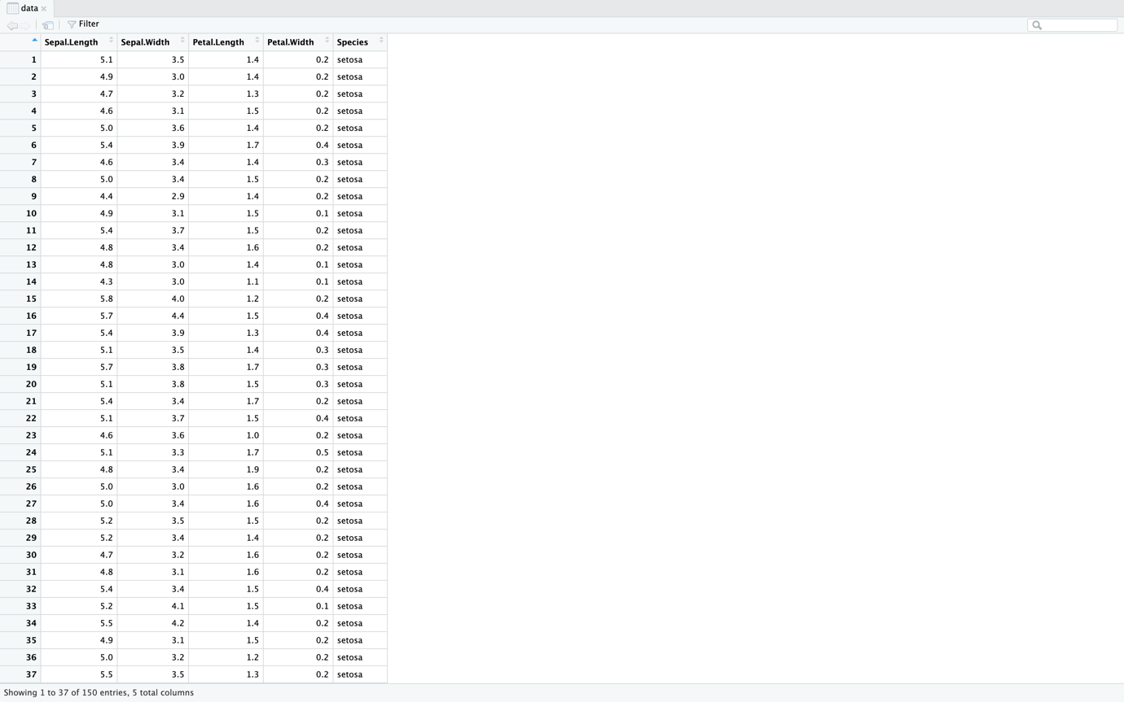

**Code:**

# dropping labels

data = data %>% select(-c("Species"))

View(data)

**Output:**

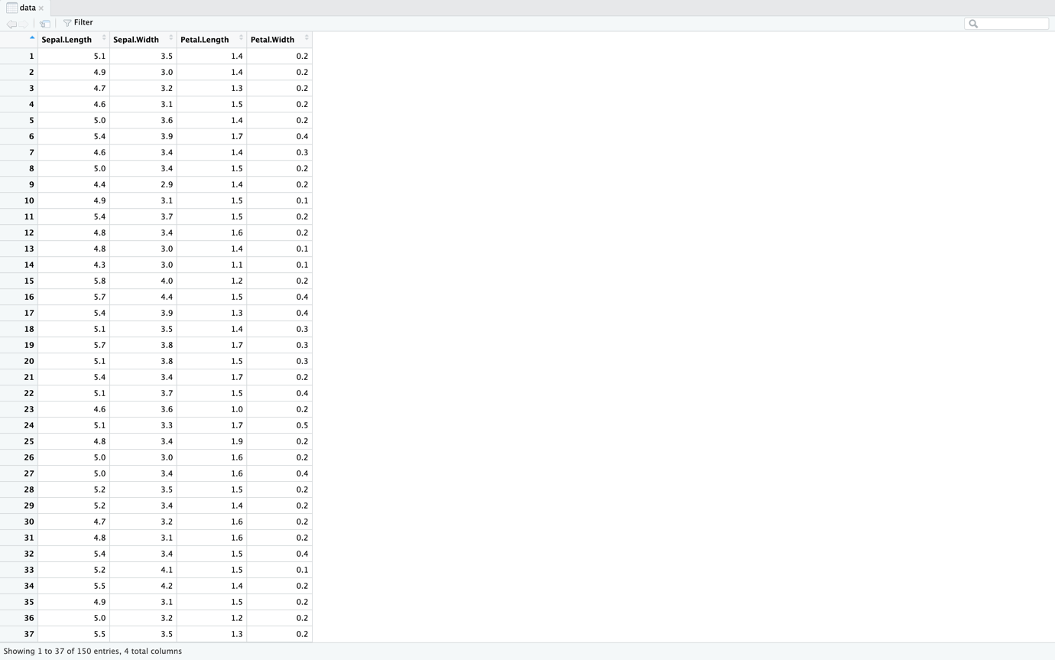

**Code:**

# adding 10% random values

iris.mis <- prodNA(data, noNA = 0.1)

View(iris.mis)

**Output:**

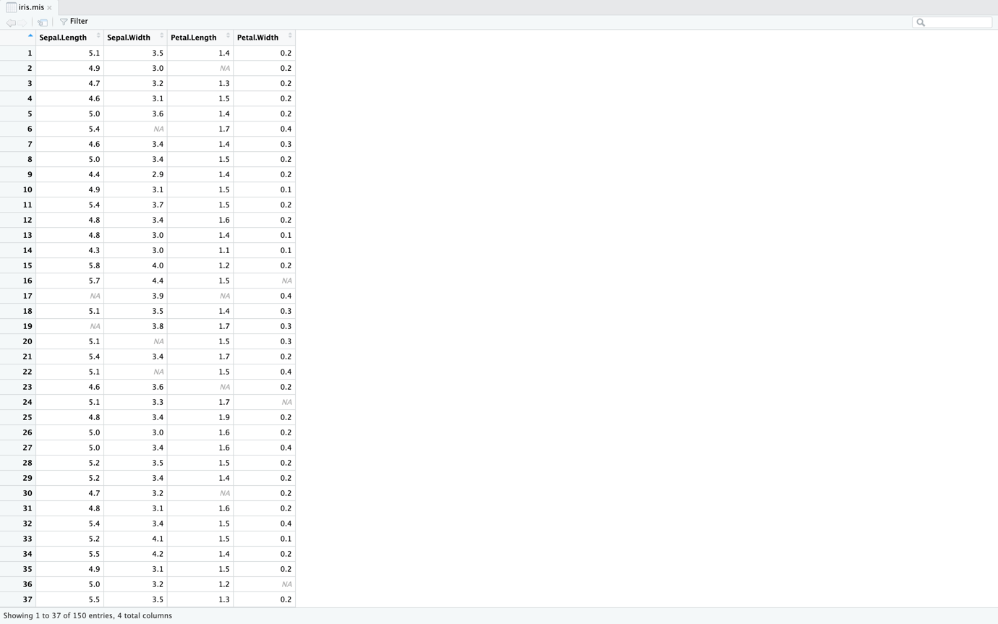

**Code:**

ggplot(iris.mis, aes(x = Sepal.Length)) +

geom_histogram(color="black", fill="#0099F8")

**Output:**

**Code:**

# simple imputations for Sepal.Length

imputed = data.frame(

Original = iris.mis$Sepal.Length,

Imp.Zero = replace(iris.mis$Sepal.Length, is.na(iris.mis$Sepal.Length), 0),

Imp.Mean = replace(iris.mis$Sepal.Length, is.na(iris.mis$Sepal.Length), mean(iris.mis$Sepal.Length, na.rm = TRUE)),

Imp.Median = replace(iris.mis$Sepal.Length, is.na(iris.mis$Sepal.Length), median(iris.mis$Sepal.Length, na.rm = TRUE))

)

# plotting the simple imputations

h1 = ggplot(imputed, aes(x=Original)) +

geom_histogram(fill="red", color="black", position="identity") +

ggtitle("Original distribution")

h2 = ggplot(imputed, aes(x=Imp.Zero)) +

geom_histogram(fill="green", color="black", position="identity") +

ggtitle("Zero-imputed distribution")

h3 = ggplot(imputed, aes(x=Imp.Mean)) +

geom_histogram(fill="blue", color="black", position="identity") +

ggtitle("Mean-imputed distribution")

h4 = ggplot(imputed, aes(x=Imp.Median)) +

geom_histogram(fill="yellow", color="black", position="identity") +

ggtitle("Median-imputed distribution")

plot_grid(h1, h2, h3, h4, nrow=2, ncol=2)

**Output:**

**Code:**

# viewing missing values

md.pattern(iris.mis, rotate.names=TRUE)

**Output:**

**Code:**

# performing imputations with mice algorithms

mice_imputed = data.frame(

Original = iris.mis$Sepal.Length,

Imp.PMM = complete(mice(iris.mis, method="pmm"))$Sepal.Length,

Imp.CART = complete(mice(iris.mis, method="cart"))$Sepal.Length,

Imp.Lasso = complete(mice(iris.mis, method="lasso.norm"))$Sepal.Length

)

# plotting the mice imputations

h1 = ggplot(mice_imputed, aes(x=Original)) +

geom_histogram(fill="red", color="black", position="identity") +

ggtitle("Original distribution")

h2 = ggplot(mice_imputed, aes(x=Imp.PMM)) +

geom_histogram(fill="green", color="black", position="identity") +

ggtitle("PMM-imputed distribution")

h3 = ggplot(mice_imputed, aes(x=Imp.CART)) +

geom_histogram(fill="blue", color="black", position="identity") +

ggtitle("CART-imputed distribution")

h4 = ggplot(mice_imputed, aes(x=Imp.Lasso)) +

geom_histogram(fill="yellow", color="black", position="identity") +

ggtitle("Lasso-imputed distribution")

plot_grid(h1, h2, h3, h4, nrow=2, ncol=2)

**Output:**

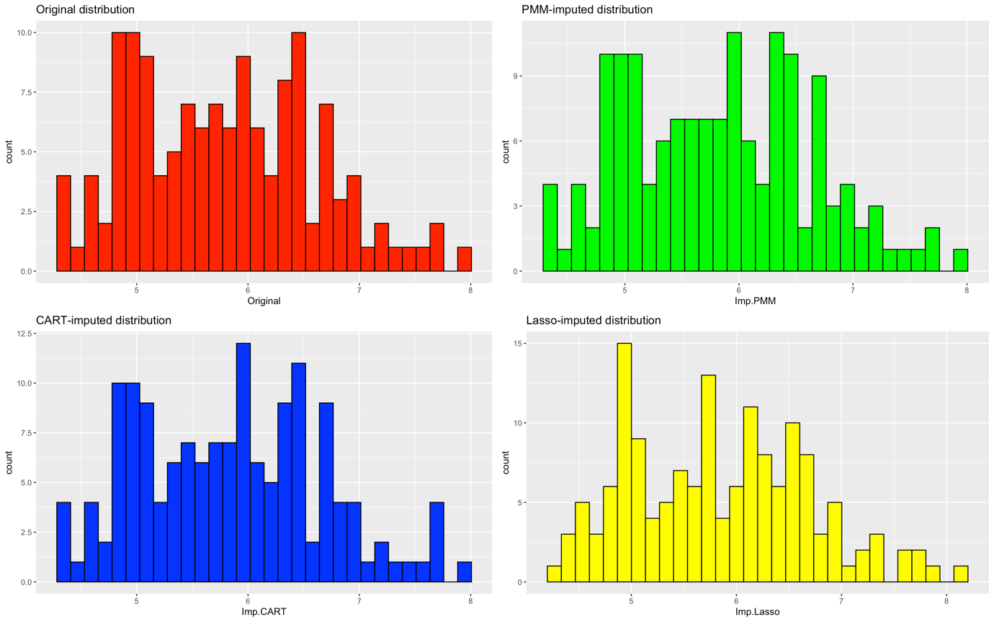

**Code:**

# imputations with missForest

missforest_imputed = data.frame(

Original = iris.mis$Sepal.Length,

Imp.Missforest = missForest(iris.mis)$ximp$Sepal.Length

)

# plotting the missForest imputations

h1 = ggplot(missforest_imputed, aes(x=Original)) +

geom_histogram(fill="red", color="black", position="identity") +

ggtitle("Original distribution")

h2 = ggplot(missforest_imputed, aes(x=Imp.Missforest)) +

geom_histogram(fill="green", color="black", position="identity") +

ggtitle("missForest-imputed distribution")

plot_grid(h1, h2, nrow=1, ncol=2)

**Output:**

